HeyGen Architecture Overview

1. Overview
HeyGen is an AI-powered video creation platform that generates avatar-based videos from text input. It combines natural language processing, voice synthesis, computer vision, and video rendering into one pipeline.

2. Architecture Workflow
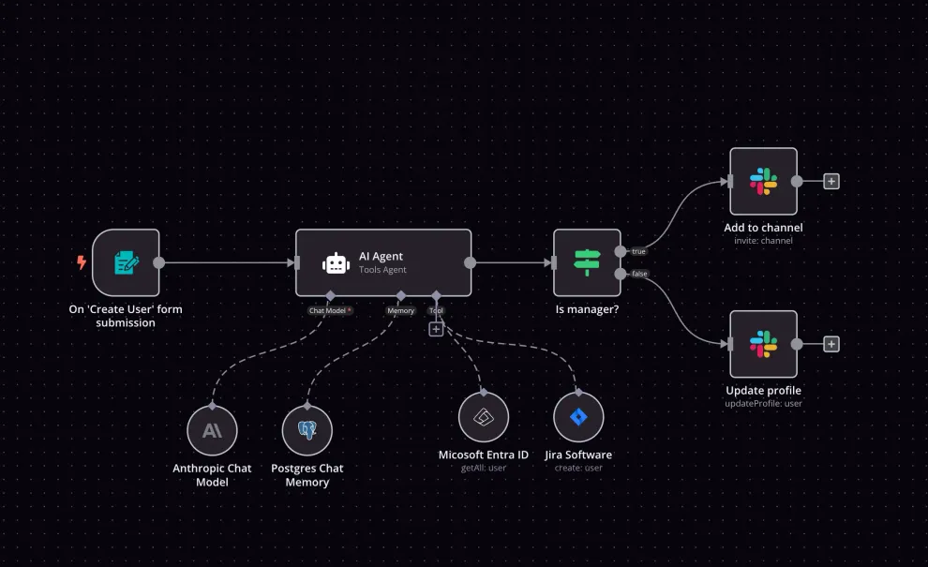
The diagram above represents the complete flow of HeyGen's video generation pipeline.

3. Component Breakdown

- Text Processing and Script Generation
Uses large language models (e.g., GPT-4) to analyze and generate scripts.

- Voice Synthesis
Uses ElevenLabs voice cloning to generate realistic speech from text.

- Lip Synchronization
Wav2Lip-2 ensures the avatar's lip movements match the generated speech.

- Avatar Generation
Utilizes GANs to generate photorealistic avatars and facial expressions.

- Video Composition
Assembles avatars, backgrounds, and synchronized audio into a single video.

- Language Translation
Supports over 40 languages, enabling real-time multilingual video output.

- Cloud Infrastructure
Uses GPU-accelerated cloud services for real-time rendering and processing.

4. Key Technologies and Libraries
• GPT-4 – Natural Language Processing
• ElevenLabs – Voice Cloning
• Wav2Lip-2 – Lip Synchronization
• GANs – Avatar Generation
• Cloud-based GPUs – High-performance video rendering

5. Development Notes
To develop a platform like HeyGen, a developer must integrate multiple subsystems, including language models, speech synthesis engines, lip-syncing modules, and video rendering pipelines. Scalability and real-time performance are achieved through cloud-based architecture.

Why HeyGen Stands Out in the Crowd
Amidst the plethora of video creation tools available, HeyGen distinguishes itself through its unique blend of advanced AI capabilities and user-friendly design. Let’s explore the key factors that set HeyGen apart from the competition.

Lightning-Fast Video Generation
One of the most impressive aspects of HeyGen is its incredible speed. Gone are the days of waiting hours or even days for your videos to render. With HeyGen, you can generate high-quality videos in a matter of minutes, ensuring that you stay ahead of the curve and never miss a crucial deadline. Whether you’re creating a short social media clip or a full-length explainer video, HeyGen’s lightning-fast processing power guarantees a seamless and efficient workflow.

authentic voiceovers that resonate with your audience.

3. Face Swapping and Customization
HeyGen’s Face Swapping feature offers:

Custom Avatars: Replace faces of lifelike human avatars and 3D avatars for a unique touch.
Close-Ups: Create engaging videos with customizable avatars and close-up shots.
Use Case: Great for adding a personal touch to your videos, enhancing engagement, and creating visually appealing content for diverse purposes.

4. Backgrounds, Music, and Text Integration
HeyGen allows seamless integration of:

Backgrounds: Set the scene with a range of background options.
Music: Enhance the mood of your videos with background music.
Text Overlays: Add text elements to convey messages effectively.
Use Case: Ideal for creating dynamic video content for social media, e-learning, presentations, and more with captivating visuals and audio elements.

HeyGen Architecture Overview
HeyGen’s architecture is designed to deliver advanced, AI-powered video generation with a focus on accessibility, scalability, and realism. Its engineering combines a modern software stack with deep learning, natural language processing, and a unique user interface paradigm.
Core Architectural Elements
- Text-First Editing Paradigm: Unlike traditional timeline-based video editors, HeyGen’s AI Studio anchors media assets (like images, gestures, and animations) directly to specific words in the script. This means visuals and actions are synchronized with the spoken text at the word level, not just by timestamp. The system detects the exact timing of each word in the audio and aligns the corresponding visuals or avatar gestures accordingly1.
- Hybrid Data Model: While users interact with a word-based interface, the underlying video rendering engine still operates on a time-based model. A real-time translation layer bridges these two paradigms, mapping word-level interactions to precise time-based outputs. This required custom adapter layers and, eventually, a full rewrite of the rendering canvas to natively support the text-centric approach1.
- Modular and Extensible Design: The architecture was deliberately modularized, allowing rapid development and integration of new features such as advanced animations, B-roll alignment, background music, and video import trimming. This modularity ensures the platform can evolve quickly and scale to handle complex, media-rich scenes1.
- Observability and Feedback Integration: Tools like LogRocket and Datadog are integrated for real-time monitoring, debugging, and user feedback, enabling the team to rapidly identify and resolve issues and iterate on user experience1.
AI and Machine Learning Foundations
- Generative AI Models: HeyGen uses deep learning neural networks to generate photorealistic avatars, synthesize natural-sounding speech, and provide accurate lip-syncing and facial expressions. These models are trained on extensive datasets to capture nuanced vocal inflections and contextually appropriate gestures5.
- Natural Language Processing (NLP): NLP enables HeyGen to process scripts in over 80 languages, ensuring accurate pronunciation and lip synchronization for global audiences7.
- Voice and Gesture Control: Features like voice mirroring (replicating a user’s tone and cadence) and gesture assignment (syncing avatar movements to specific words) are enabled by tightly integrated AI and custom modeling15.
API and Integration
- HeyGen offers a robust API, allowing developers to programmatically generate videos, customize backgrounds (color, image, video, or transparent), and integrate HeyGen’s capabilities into other applications6. The API is secured via tokens and supports cloud-hosted operations for scalability26.
Event-Driven SDK
- The Streaming Avatar SDK uses an event-driven architecture, allowing developers to listen for and respond to avatar events (e.g., when an avatar starts or stops talking), further enhancing integration flexibility4.

Component | Description
Editing Paradigm | Text-first (word-based), mapped to time-based rendering
AI/ML Technologies | Deep learning, generative AI, NLP, neural networks
Avatar Capabilities | Photorealistic avatars, gesture control, voice mirroring, multilingual support
Modularity | Modular, extensible canvas and feature architecture
Observability | Real-time monitoring and feedback (LogRocket, Datadog)
API/SDK | Secure, event-driven, supports video, image, color, and transparent backgrounds

