Hour One - AI Video Generation Architecture

1. Overview
Hour One is an AI video generation platform that transforms written scripts into professional videos using realistic avatars. It automates the video production pipeline and is used in education, corporate training, e-learning, and marketing.

2. Architecture Workflow Diagram

The diagram illustrates the step-by-step architecture of the Hour One video generation process.

3. System Components and Descriptions

- Script Input & Analysis
Uses GPT-like models to understand and segment text input into speakable script.

- Voice Generation
Employs high-quality Text-to-Speech (TTS) engines, likely including ElevenLabs, Amazon Polly, or proprietary tech.

- Avatar Selection
Avatars are based on real human actors and stored as video models. Users select from a pre-recorded library.

- Lip Syncing
Likely powered by models such as Wav2Lip for precise audio-to-lip synchronization.

- Video Rendering
Generative models like GANs or NeRF-based technologies create video clips from avatars and voice data.

- Customization Layer
Allows background selection, brand overlays, text boxes, and visuals to be integrated into the video.

- Cloud Infrastructure
The platform is hosted on GPU-powered cloud systems to allow real-time or batch video processing.

4. Libraries, Models, and Tools (Inferred)
• GPT-3 or GPT-4 – For text analysis and content adaptation.
• ElevenLabs / Polly / Azure TTS – For multilingual voice generation.
• Wav2Lip – Deep learning model for lip sync.
• GANs / NeRF – Used for avatar animation and realism.
• ReactJS / WebAssembly – For live preview and rendering.
• AWS / GCP Cloud GPUs – For infrastructure and scalability.

5. Use Cases
• Employee onboarding and training videos
• Automated e-learning content
• News and media broadcasts
• Marketing explainers and product demos
• Customer support tutorials with avatars

6. Summary
Hour One simplifies the video production process by combining avatars, TTS, NLP, and video editing into one AI-powered platform. It is ideal for businesses looking to scale video content creation across languages and industries.

Using AI to simplify the video creation process
One of the biggest barriers to video content creation is the “blank canvas effect,” where users struggle to start from scratch. Hour One’s vision was to provide an AI copilot that simplifies the video creation process, allowing users to generate scripts with a single sentence or prompt. By integrating Azure OpenAI Service, Hour One’s Reals platform generates initial text for videos based on user prompts, dramatically reducing the time and effort required to create compelling scripts.
When building the Reals platform, they wanted users to be able to use a single sentence or detailed prompt to create complete scaffold of a video, dramatically reducing the time and effort required to create compelling scripts. Reals also needed to provide customizable backgrounds and other elements, ready for tweaking. Beyond this, the platform would have to allow for titles, images, and text to be effortlessly fine-tuned and then render the final video quickly.
Other technical challenges included:
- All speech in the video had to be as natural as possible.
- Speed and performance were a must to produce immediate results and to iterate quickly even under demand conditions.
- Content had to be dynamic so users could view and update the video before publishing. (If the editing process took days to complete, the platform would not be usable.)
- Performance could not degrade, meaning the platform had to achieve the same immediate results even as the number of users scaled sky-high.

Azure Services Used by Hour One
When evaluating the technological landscape and determining which provider would best fit their needs, Hour One landed on using a range of Azure services for their Reals platform.

Using Azure OpenAI Service to generate video scripts based on user prompts
Azure OpenAI Service provides access to one of the world’s most advanced generative AI models combined with Azure AI-optimized infrastructure, enterprise-readiness, compliance, data security, and privacy controls, along with many integrations with other Azure services. The Reals platform uses Azure OpenAI Service to create prefilled scripts with multiple scenes and compelling text based on a simple one-line prompt from the user, helping to produce high-quality content quickly and easily.

Using Azure OpenAI Service to generate video scripts based on user prompts
Azure OpenAI Service provides access to one of the world’s most advanced generative AI models combined with Azure AI-optimized infrastructure, enterprise-readiness, compliance, data security, and privacy controls, along with many integrations with other Azure services. The Reals platform uses Azure OpenAI Service to create prefilled scripts with multiple scenes and compelling text based on a simple one-line prompt from the user, helping to produce high-quality content quickly and easily.

Deploying the Hour One solution
According to Hour One CTO Lior Hakim, “Azure’s scalability and reliability have allowed us to process vast amounts of data, train complex algorithms, and optimize our model’s performance, ultimately providing our customers with a superior video creation experience.”
Here’s a brief overview of the video creation process using the Reals platform:
- User input from the Reals web client or a mobile client passes through the API to the AKS infrastructure powering the platform.
- Azure OpenAI generates initial text for the user’s video based on a prompt provided by the user or fills in text on a video template.
- This text is passed back to AKS, which renders the video, matching up expressions and facial movements with the generated text.
- The user can then tweak the video, selecting a different virtual human and modifying the text, background, and many other features, until they are completely satisfied.
- The Reals platform uses a proprietary microservices architecture to render the final high-quality video.
Here’s what the process looks like at a schematic level:

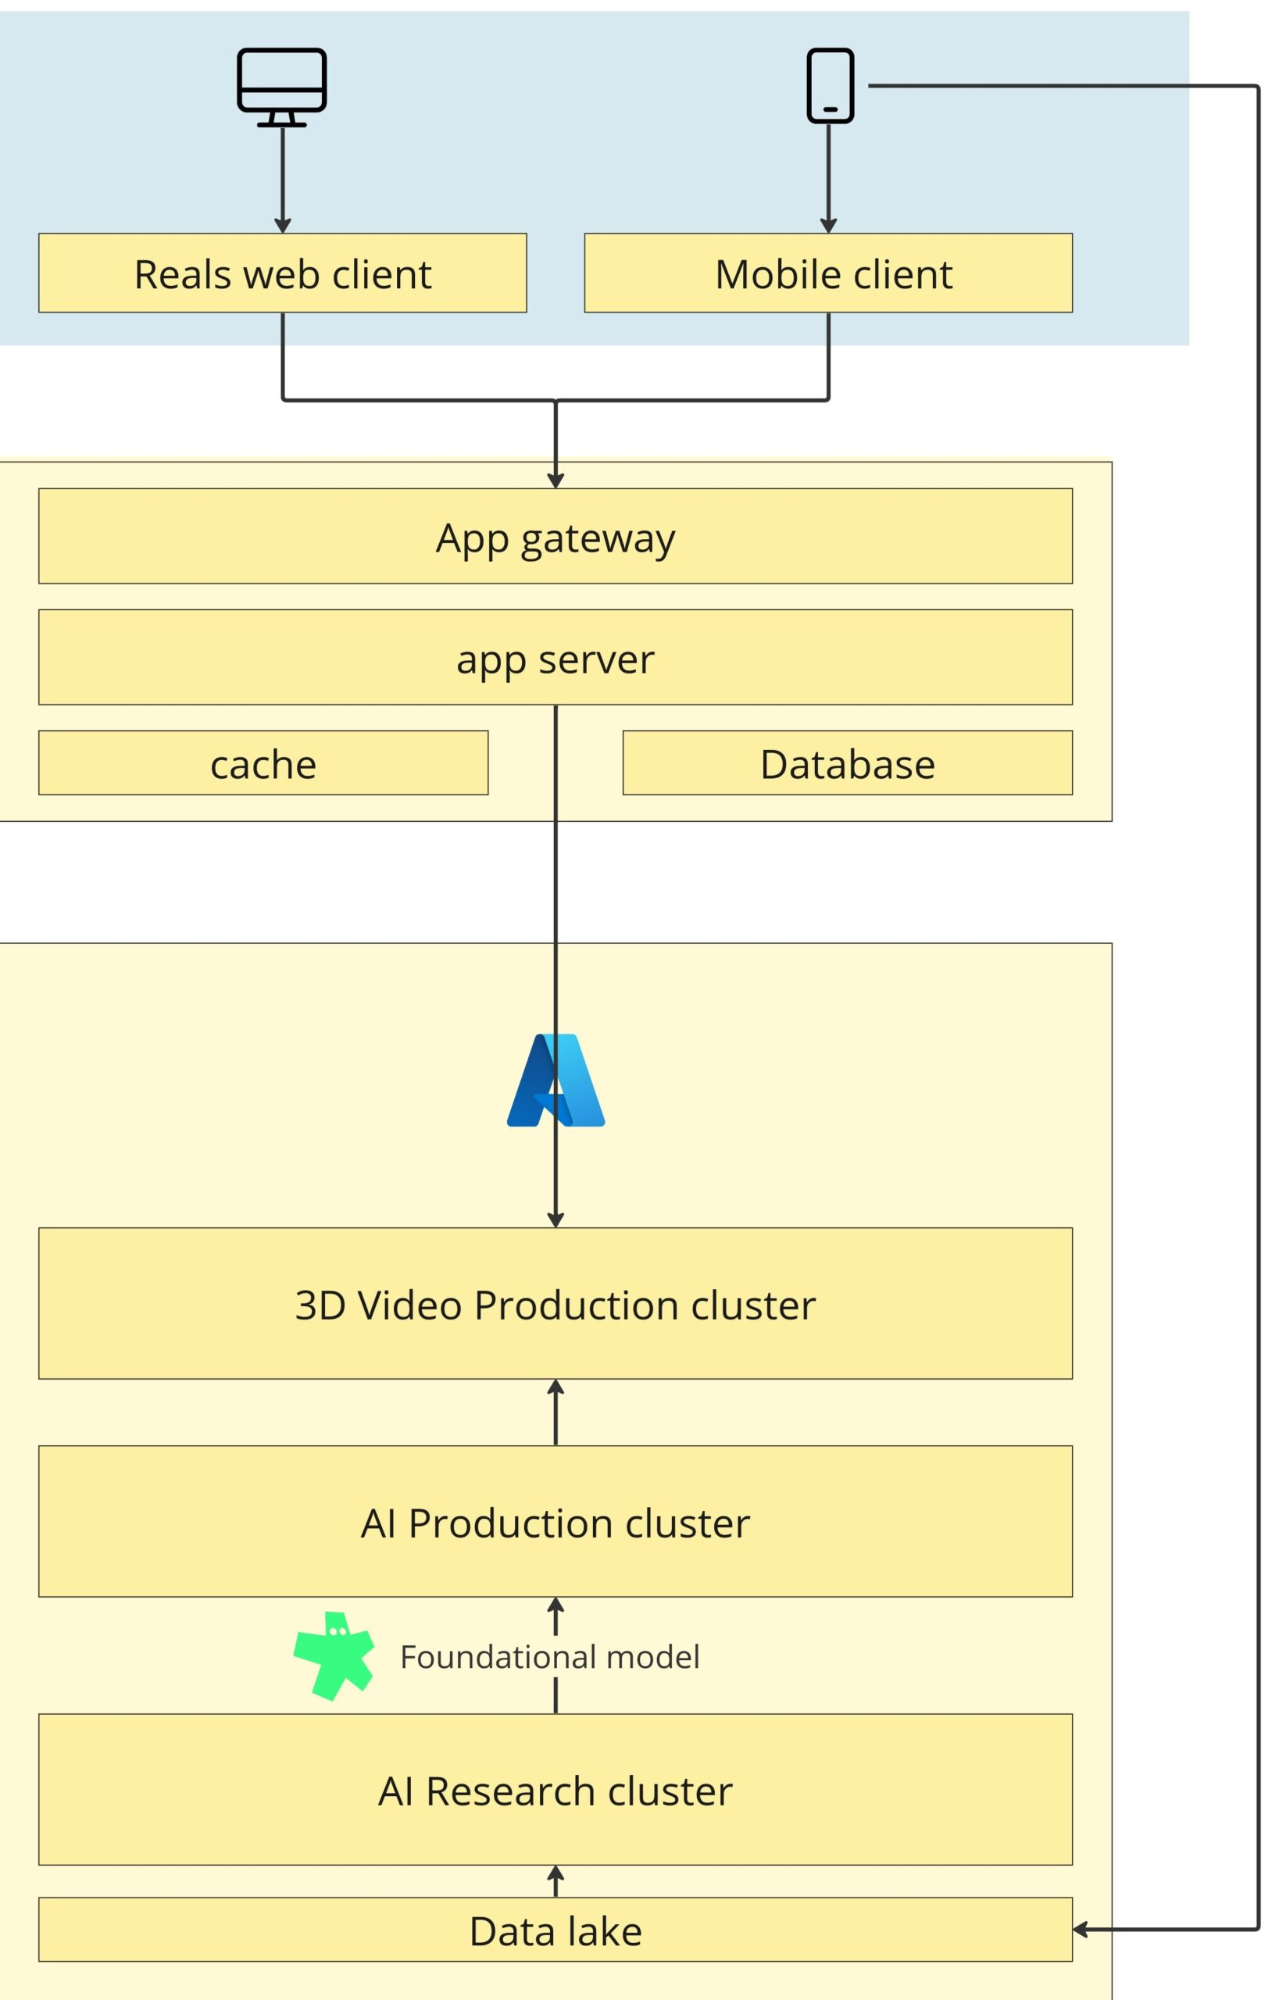

Techniques, Technologies, Libraries, and Tools
- Cloud Services:
  - Google Cloud Platform (GCP): For compute, storage, and networking5.
  - Google Kubernetes Engine (GKE): For container orchestration and scaling5.
  - Cloud GPUs (including L4s): For high-speed AI inference and video rendering5.
- AI/ML Frameworks:
  - Deep learning libraries (likely TensorFlow or PyTorch) for model development and inference (inferred from industry standards).
  - NLP toolkits for language processing and translation (e.g., spaCy, Hugging Face Transformers; not explicitly stated but standard in the field).
- Media Processing:
  - Video and audio processing libraries (e.g., FFmpeg, OpenCV; inferred).
- Frontend/UI:
  - Web technologies for the user interface (React, Vue.js, or similar frameworks are typical for such platforms; not explicitly stated).
- Collaboration & Workflow:
  - Real-time collaboration tools and workspace management features are built into the platform3.
- Observability & Monitoring:
  - Cloud-native monitoring tools (such as Google Cloud Monitoring; inferred).

Summary Table: Hour One Architecture
Component | Technology/Technique | Purpose
Cloud Infrastructure | Google Cloud, GKE, Cloud GPUs | Scalable compute, fast rendering, cost control5
AI/ML Engine | Deep learning, NLP, TTS | Script-to-video, avatar animation, translation36
Media Processing | Media libraries, file conversion | Visual/audio integration, scene creation36
User Interface | Web-based (React/Vue.js, inferred) | No-code editing, templates, collaboration34
Collaboration | Built-in team tools | Real-time/offline co-creation, feedback3
Monitoring | Cloud-native tools (inferred) | Observability, reliability

